Ramadan Friday 29/03/2024

Lesson 116 and 117

Github Repo Visibility: Public Vs, Private

Example 1 below

Click on settings

Example 2

It visible to anybody now

I want to change the visibility

Lesson 118

Adding Github Collaborators

Example 1

Allowing collaborators will ensure you’re able to push repo into the public.

People need collaboration previleges on a

Click settings

Now I need to go to my email and accept this inivitation is better to use username as its faster

[abiolaosota@gmail.com](mailto:abiolaosota@gmail.com)

Still waiting I cancelled and used username

Once you’re collaborators you don’t have access to settings of that repo

Ramadan Monday 01/04/2024

Lesson 119

Github collaboration Demo

Now I want to pretend to be 2 users

Tuesday Ramadan 02/04/2024

I want to rename my master branch

Before I can push I need to add remote to it

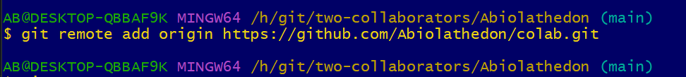

I will check the github repo now.

This is on the main branch

I will go back to Abiola-dev account to see

Abiola-dev want to get this on my machine and start working on it. I need to clone it to my machine.

I will switch into Abiola-dev here the 2nd collaborator

Remember you don’t run git init here because you’re cloning

The repo is cloned now.

Now I want to push to git hub now

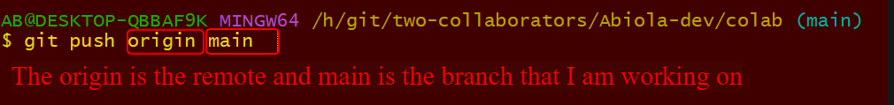

This is Abiola-dev

This you can see.

Now how do the Abeythedon get this changes?

Lesson 120

What are READMs?

<https://github.com/jasontaylordev/CleanArchitecture>

<https://github.com/explosion/spaCy>

<https://github.com/facebook/react>

Wednesday Ramadan 03/04/2024

Is better you put the read me file inside the root of the directory as github automatically pick that up. Learn more about readme…

Lesson 121

A Markdown Crash Course

README.md

<https://daringfireball.net/projects/markdown/>

<https://markdown-it.github.io/>



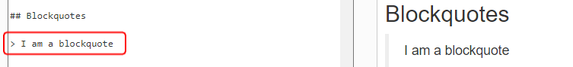

Lesson 122

Adding a README To A Project

It’s a make down file.

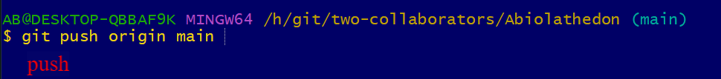

It detect read me.

In the local machine

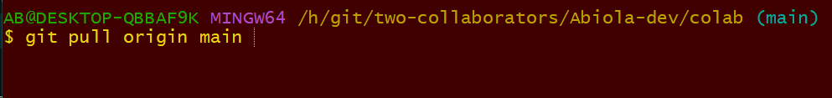

Lesson 123

Creating Github Gists

<https://gist.github.com/discover>

<https://gist.github.com/oanhnn/80a89405ab9023894df7>

You can also add description also

Lesson 124

Introducing Github Pages

<https://pages.github.com/>

<https://github.com/ovolve/2048-AI>

<https://ovolve.github.io/2048-AI/>

<https://github.com/faker-js/faker>

I will focus on Project Sites

Any repo you make you can have your own website.

Username.github.io/repo-name

Lesson 125

Github Pages Demo

<https://colt.github.io/chickens/>

Now I want to setup github page website. I have to tell a branch that has index.html file

I will create a new branch now

<!DOCTYPE *html*>

<html *lang*="en">

<head>

    <meta *charset*="UTF-8">

    <meta *name*="viewport" *content*="width=device-width, initial-scale=1.0">

    <title>Chickens</title>

</head>

<body>

    <h1>Chickens!</h1>

    <p>Lorem ipsum dolor sit, amet consectetur adipisicing elit. Totam accusantium numquam eveniet officia! Nulla dolores optio officia placeat ipsum eaque explicabo enim sit, quaerat hic, molestiae tenetur eius! Quisquam, amet!</p>

</body>

</html>

<!DOCTYPE *html*>

<html *lang*="en">

<head>

    <meta *charset*="UTF-8">

    <meta *name*="viewport" *content*="width=device-width, initial-scale=1.0">

    <title>Chickens</title>

</head>

<body>

    <svg *viewBox*="0 0 600 300">

*<!-- Symbol-->*

        <symbol ***id***="s-text">

            <text *text-anchor*="middle" *x*="50%" *y*="50%" *dy*=".35em">Chickens!</text>

        </symbol>

*<!-- Duplicate symbols-->*

        <use *class*="text" *xlink:href*="#s-text"></use>

        <use *class*="text" *xlink:href*="#s-text"></use>

        <use *class*="text" *xlink:href*="#s-text"></use>

        <use *class*="text" *xlink:href*="#s-text"></use>

        <use *class*="text" *xlink:href*="#s-text"></use>

    </svg>

</body>

</html>

My html sorry

*/* Main styles */*

@import url(https://fonts.googleapis.com/css?family=Open+Sans:800);

*.text* {

  fill: none;

  stroke-width: 3;

  stroke-linejoin: round;

  stroke-dasharray: 70 330;

  stroke-dashoffset: 0;

*-webkit-animation*: stroke 6s infinite linear;

  animation: stroke 6s infinite linear;

}

*.text:nth-child*(5n+1) {

  stroke: **#F2385A**;

*-webkit-animation-delay*: -1.2s;

  animation-delay: -1.2s;

}

*.text:nth-child*(5n+2) {

  stroke: **#F5A503**;

*-webkit-animation-delay*: -2.4s;

  animation-delay: -2.4s;

}

*.text:nth-child*(5n+3) {

  stroke: **#E9F1DF**;

*-webkit-animation-delay*: -3.6s;

  animation-delay: -3.6s;

}

*.text:nth-child*(5n+4) {

  stroke: **#56D9CD**;

*-webkit-animation-delay*: -4.8s;

  animation-delay: -4.8s;

}

*.text:nth-child*(5n+5) {

  stroke: **#3AA1BF**;

*-webkit-animation-delay*: -6s;

  animation-delay: -6s;

}

@-webkit-keyframes stroke {

*100%* {

    stroke-dashoffset: -400;

  }

}

@keyframes stroke {

*100%* {

    stroke-dashoffset: -400;

  }

}

*/* Other styles */*

html, body {

  height: 100%;

}

body {

  background: **#111**;

  background-size: 0.2em 100%;

  font: 5em/1 Open Sans, Impact;

  text-transform: uppercase;

  margin: 0;

}

svg {

  position: absolute;

  width: 100%;

  height: 100%;

}

Below is html again

<!DOCTYPE *html*>

<html *lang*="en">

<head>

    <meta *charset*="UTF-8">

    <meta *name*="viewport" *content*="width=device-width, initial-scale=1.0">

    <title>Chickens</title>

    <link *rel*="stylesheet" *href*="app.css">

</head>

<body>

    <svg *viewBox*="0 0 600 300">

*<!-- Symbol-->*

        <symbol ***id***="s-text">

            <text *text-anchor*="middle" *x*="50%" *y*="50%" *dy*=".35em">Chickens!</text>

        </symbol>

*<!-- Duplicate symbols-->*

        <use *class*="text" *xlink:href*="#s-text"></use>

        <use *class*="text" *xlink:href*="#s-text"></use>

        <use *class*="text" *xlink:href*="#s-text"></use>

        <use *class*="text" *xlink:href*="#s-text"></use>

        <use *class*="text" *xlink:href*="#s-text"></use>

    </svg>

</body>

</html>

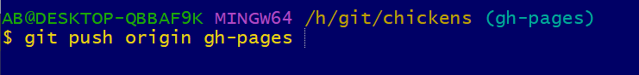

This is static website.